# CS 255 System Design Document Template

This template lays out all the different sections that you need to complete for Project Two. Each section has guidance to prompt your thinking. You will need to continually reference the interview transcript as you work to make sure that you are addressing your client’s needs. There is no required length for the final document. Instead the goal is to complete each section based on what your client’s needs are. Remove this note when you are finished, and replace all bracketed text with the relevant information.

## UML Diagrams

### UML Use Case Diagram

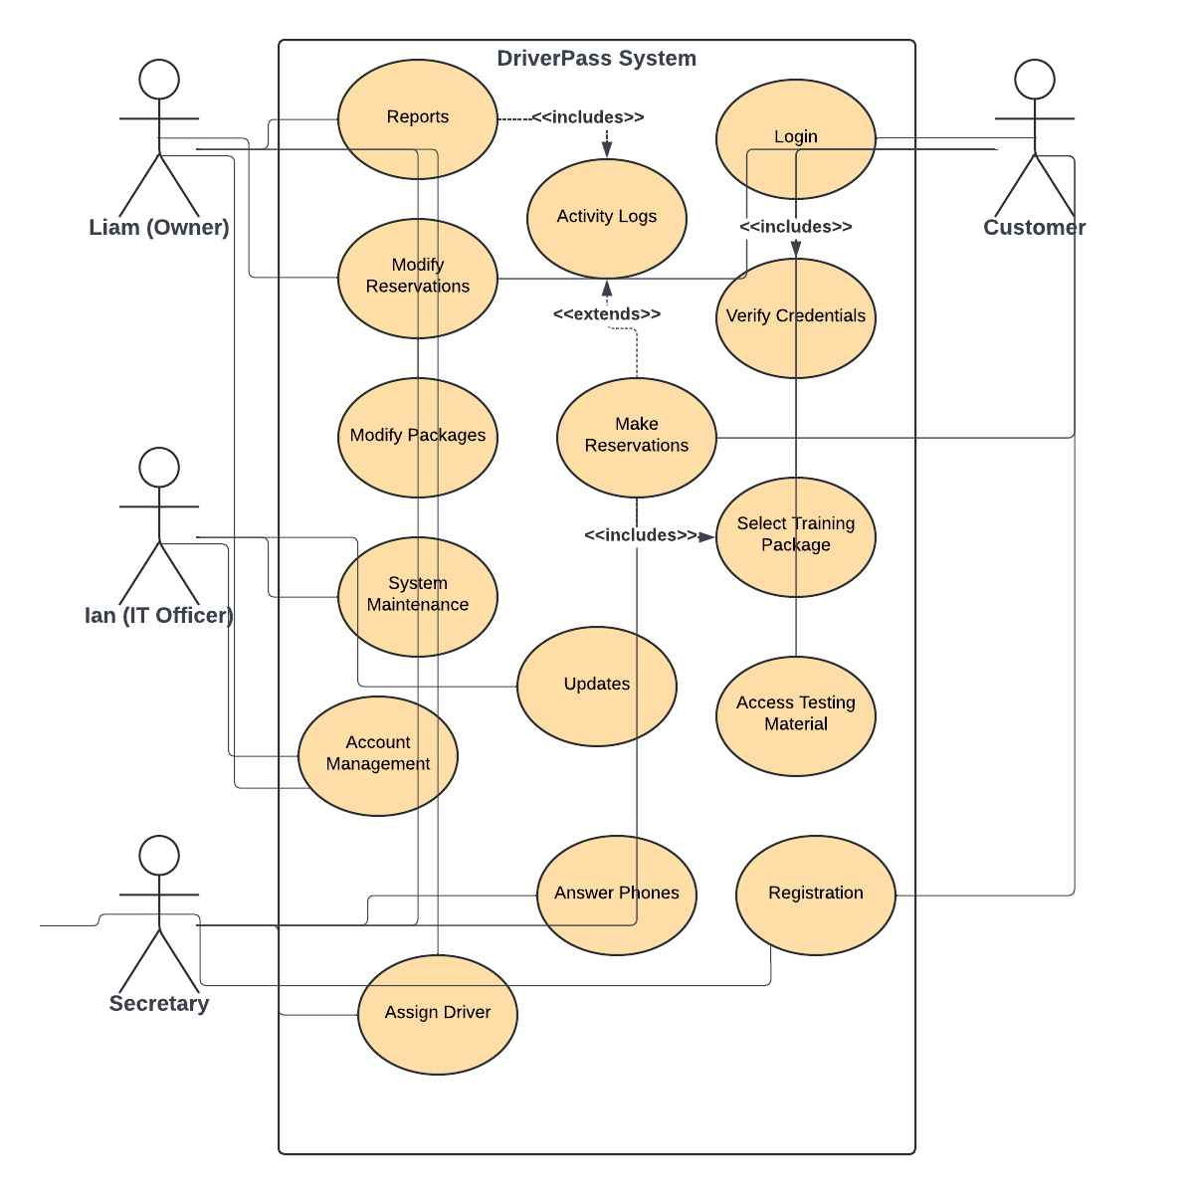

### UML Activity Diagrams

### UML Sequence Diagram

### UML Class Diagram

## Technical Requirements

To implement the DriverPass system as it has been illustrated throughout this design document, the technical requirements will include the availability of hardware to run servers as well as devices for the clients to access these servers. Software will also be required to run the server-side and client-side software, development tools to carry out the programming needed for server set-up as well as the web development. It is also critical that the system utilizes a scalable infrastructure to ensure an easier transition to a larger system once necessary. This system must maintain high availability, security, and high performance to support both online and offline access, user authentication, access controls, activity logs, and notifications. The system must be made available on both mobile devices and PCs.